Koneru Lakshmaiah Education Foundation
(Deemed to be University)

Course Code: 22SDEC06R
Course Name: Embedded Design
(Skill Development Project-3)
A Project Report
On
Project Title
SMART HELMET WITH TELEGRAM BOT FOR RIDER SAFETY

SUBMITTED BY:
I.D NUMBER : 2300049069 – P.N N TEJASWI
2300049074 – P.VIVEKVARDHAN
2300049081- M.SRIKHARI
2300049114- P.USMAN

UNDER THE GUIDANCE OF
Dr Aswin Kumer S V
Associate Professor-ECE, HoD-EL&GE

Green fields, Vaddeswaram – 522 502
Guntur Dist., AP, India.

K L E F

DEPARTMENT OF ELECTRONICS AND COMMUNICATION ENGINEERING
(DST-FIST Sponsored Department)



DECLARATION

The Project Report entitled “SMART HELMET WITH TELEGRAM BOT FOR RIDER SAFETY” is a record of bonafide work of 2300049069 – P.N N TEJASWI, 2300049074- P.VIVEKVARDHAN, 2300049081- M.SRIKHARI, 2300049114- USMAN, submitted in partial fulfillment for the award of B.Tech in Electronics and Communication Engineering to the K L University. The results embodied in this report have not been copied from any other departments/University/Institute.

K L E F

DEPARTMENT OF ELECTRONICS AND COMMUNICATION ENGINEERING
(DST-FIST Sponsored Department)


CERTIFICATE
This is to certify that the Project Report entitled “SMART HELMET WITH TELEGRAM BOT FOR RIDER SAFETY” is being submitted 2300049069 – P.N N TEJASWI, 2300049074- P.VIVEKVARDHAN, 2300049081- M.SRIKHARI, 2300049114- USMAN,submitted in partial fulfilment for the award of B.Tech in Electronics and Communication Engineering to the K L University is a record of bonafide work carried out under our guidance and supervision.
The results embodied in this report have not been copied from any other departments/ University/Institute.
Signature of Supervisor
Signature of the HOD Signature of the External Examiner

ACKNOWLEDGMENT

It is great pleasure for me to express my gratitude to our honourable President Sri. Koneru Satyanarayana, for giving the opportunity and platform with facilities in accomplishing the project report.
I express the sincere gratitude to our Vice Chancellor, Dr G P S Varma for his administration towards our academic growth.
I express the sincere gratitude to our Pro VCs, Dr N Venkatram & Dr K Raja Sekara Rao for their administration towards our academic growth.
I record it as my privilege to deeply thank our principal, Dr.V. Rajesh for providing us the efficient faculty and facilities to make our ideas into reality.
I express sincere gratitude to our pioneer Dr I Govardhani, HOD-ECE for his leadership and constant motivation provided in successful completion of our academic semester.
I express my sincere thanks to our project mentors Dr Aswin Kumer S V, Associate Professor, ECE & HoD-EL&GE for their novel association of ideas, encouragement, appreciation, and intellectual zeal which motivated us to venture this project successfully.
Finally, it is pleased to acknowledge the indebtedness to all those who devoted themselves directly or indirectly to make this project report success.

ABSTRACT
Road accidents resulting from drunk driving and delayed emergency responses represent a critical global safety challenge. This project proposes an IoT-based Smart Helmet designed to enhance rider protection by integrating alcohol detection and automated accident reporting. Utilizing an ESP32 microcontroller, the system employs an MQ-3 sensor to monitor the rider’s breath for alcohol and an impact sensor to detect collisions. If intoxication is detected, the system proactively prevents the motorcycle from starting. In the event of a crash, the system utilizes a Neo-6M GPS module to pinpoint the rider’s coordinates and transmits an instant emergency alert, including a Google Maps location link, via a Telegram Bot. This solution aims to minimize rescue time and significantly increase survival rates
Literature Survey
The Smart Helmet is an IoT-based safety system powered by an ESP32 microcontroller designed to reduce road accident fatalities.
Key Functionalities:
- Alcohol Prevention: Uses an MQ-3 sensor to detect alcohol in a rider's breath; if detected, a relay module disables the bike's ignition.
- Crash Detection: An impact sensor (SW-420) identifies sudden vibrations or accidents automatically.
- Emergency Alerts: When a crash occurs, a Neo-6M GPS module captures the location, and the ESP32 sends an instant Telegram Bot alert containing a Google Maps link to emergency contacts

INDEX
S.NO | TITLE
1 | Introduction
2 | Aim of the Project
3 | Proposed Methodology  (Include Block Diagram/Flow Chart)
4 | Components Explanation
5 | Implementation Methodology  (Circuit and Implementation)
6 | Results and Discussions  (With Screenshots)
7  8 | Source Code  Conclusion and Future Scope

- Introduction:
Road safety has reached a critical point due to rising fatalities caused by driver negligence and alcohol consumption. A primary factor in severe injuries and deaths is the lack of immediate medical assistance following an accident. There is a pressing need for an intelligent system that can both prevent accidents through proactive monitoring and provide immediate assistance when they occur. By integrating modern sensors and IoT technology, the proposed Smart Helmet offers a robust layer of protection for motorcyclists.

- Problem Statement
The current road safety landscape is plagued by two primary issues that this project seeks to solve:
- Preventable Negligence: Alcohol consumption is a leading cause of motorcycle accidents globally. Traditional helmets provide physical protection but do not proactively prevent a rider from operating a vehicle while intoxicated.
- The Communication Gap: In many accidents, victims suffer severe injuries or fatalities not from the initial impact, but because they are unable to call for help. Relying on manual emergency reporting often results in missing the "golden hour" for medical intervention.
3. Detailed System Architecture
The system architecture is designed as a closed-loop IoT ecosystem where the ESP32 serves as the central processing unit.
- Input Layer: Consists of the MQ-3 sensor (chemical input), SW-420/MPU6050 (mechanical/vibration input), and the Neo-6M GPS (geospatial input).
- Control Layer: The ESP32 processes these inputs to make real-time decisions, such as whether to trigger the Relay Module or initiate a Wi-Fi-based emergency broadcast.
- Output Layer: Includes physical indicators like LEDs and Buzzers for the rider, and a cloud-based Telegram Bot for external emergency contacts.
4. Hardware Component Analysis
- ESP32 Microcontroller: Chosen for its dual-core processing and built-in Wi-Fi functionality, which is critical for maintaining a connection to the Telegram API without needing extra modules.
- MQ-3 Alcohol Sensor: This sensor is specifically tuned to detect alcohol concentration in the breath; it acts as a gatekeeper for the bike's ignition.
- Neo-6M GPS Module: This module provides the essential latitude and longitude coordinates that turn a simple alert into a precise rescue tool.
- Relay Module: Integrated into the motorcycle's starter circuit, it provides the physical "kill-switch" capability based on the sensor data.

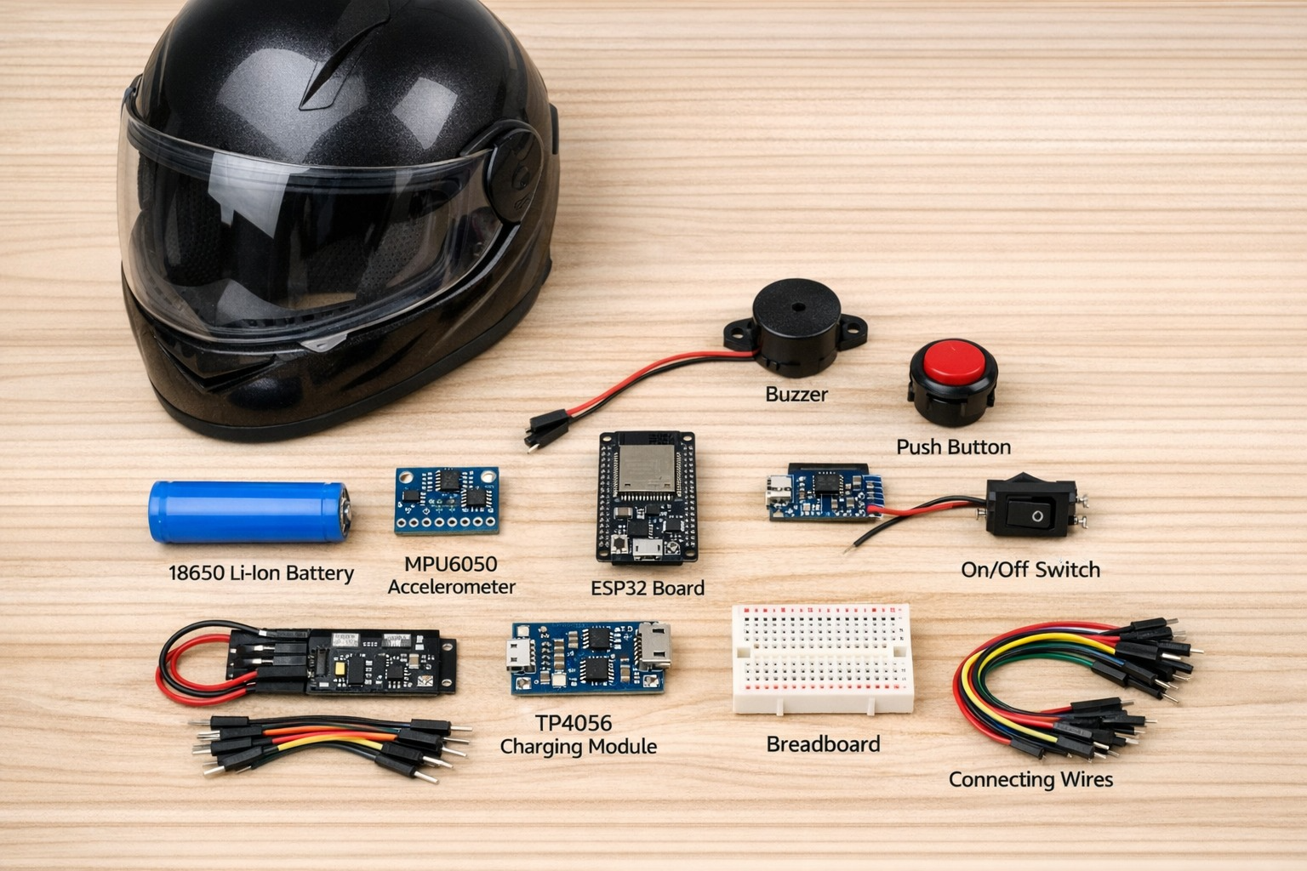
5. Comprehensive Working Methodology
The system's operation is divided into three distinct operational phases:
- Safety Verification (Pre-Ignition): Upon powering the helmet, the MQ-3 sensor undergoes a warm-up phase to analyze the surrounding air. If alcohol is detected above the safe threshold, the ESP32 sends a signal to the Relay Module to keep the ignition circuit open, effectively disabling the motorcycle.
- Continuous Monitoring (In-Transit): While riding, the SW-420 impact sensor or MPU6050 accelerometer monitors for sudden G-force changes or intense vibrations.
- Autonomous Emergency Protocol: If a crash is identified, the system immediately pulls data from the Neo-6M GPS. It then utilizes the Telegram Bot API to send an instant notification to predefined contacts. This notification includes a direct Google Maps link, allowing rescuers to navigate directly to the rider's coordinates.

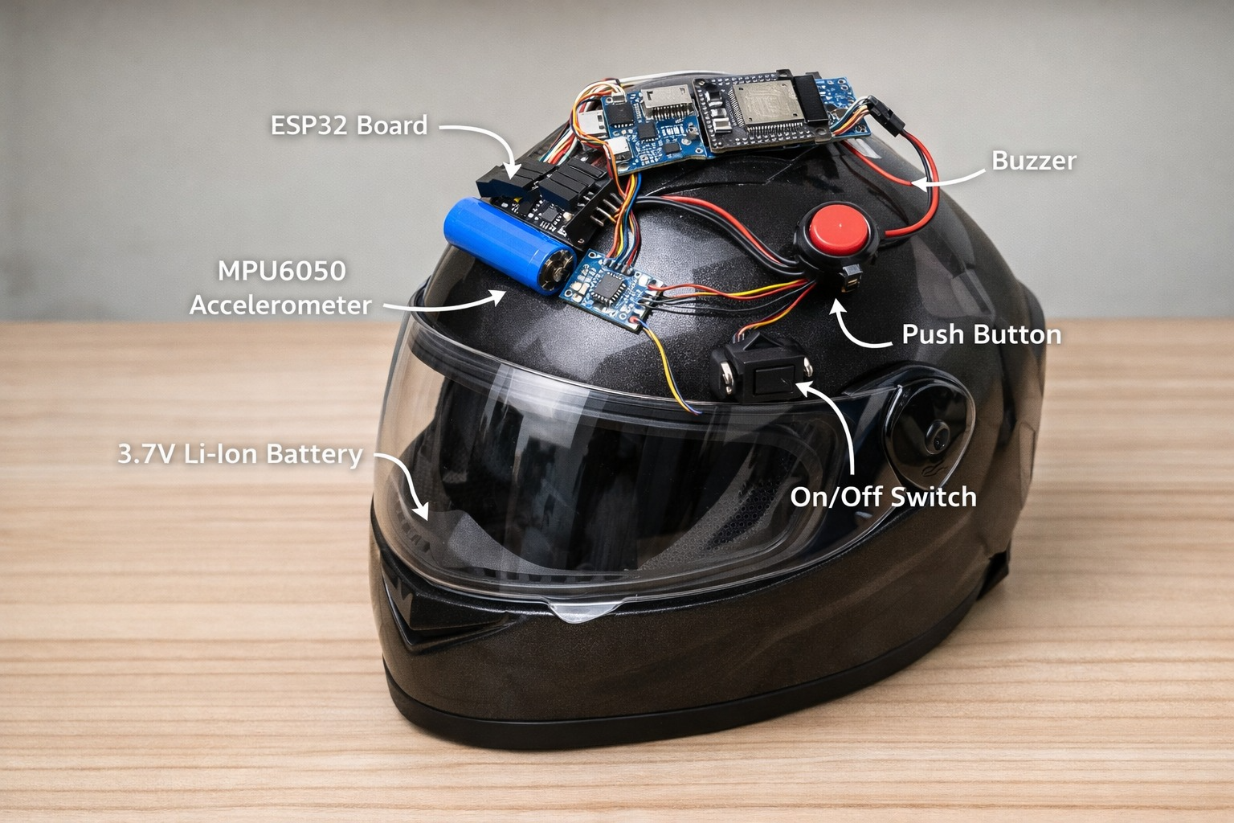
6. Expanded Applications and Use Cases
The versatility of the Smart Helmet allows for implementation across various sectors:
- Logistics and Food Delivery: Ensuring that fleet riders are operating safely and providing companies with a way to monitor emergency situations instantly.
- Bike Taxi Platforms: Enhancing passenger trust by ensuring that drivers are sober and that help is just seconds away in case of an incident.
- University and Corporate Campuses: Promoting a culture of safety for students and employees.
- Government Initiatives: Integration into broader traffic safety programs to reduce national accident fatality rates.
7. Future Scope and Enhancements
The system is designed to be scalable for future technological integrations:
- Health Monitoring: Adding heartbeat monitoring sensors to provide medical teams with the victim's vital signs before they even arrive at the scene.
- Evidence Collection: Integrating a camera module to record the events leading up to an accident for insurance or legal purposes.
- AI Integration: Utilizing AI-based accident prediction to warn riders of potential hazards before an impact occurs.
- Cloud Ecosystem: Storing all safety and accident data in the cloud for long-term safety analytics and road risk mapping.
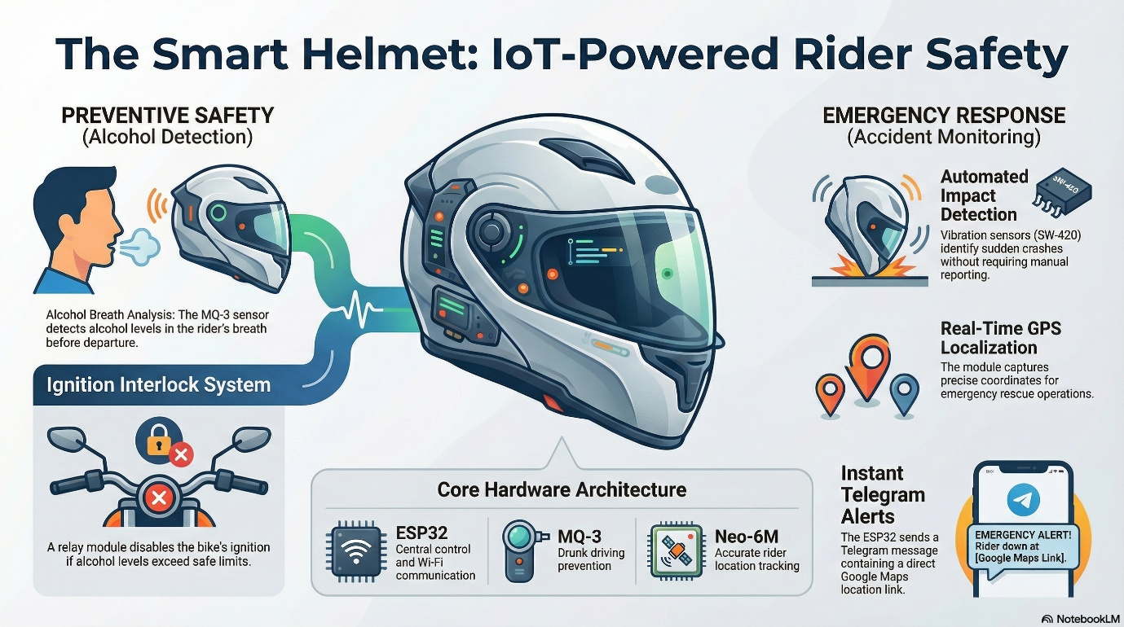

8. Conclusion
The Smart Helmet project successfully demonstrates that IoT-based smart technology can be a low-cost, practical, and highly scalable solution to global road safety challenges. By moving from passive protection to active prevention and autonomous reporting, this system has the potential to transform transportation safety and save countless lives

